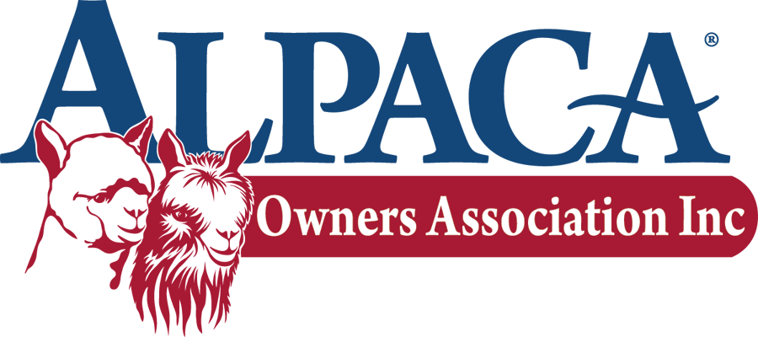
Student Design Competition

Alpaca Sample ORder FORM
Please indicate the types of items you'd like for us to include. Quantities are limited, but we'll do our best to send you an assortment of colors within the item typed based on the number of students you indicate. Samples may only be requested by instructors. Each sample pack has enough materials for 3 – 5 students, with a variety of colors.
Ship To
Instructor Name
School
Street Address
City, State, Zip
Email Address
Category ~ Textile ~ Fashion
Number  Students | Item | Description |  | Color | Total Ordered
 | yarn huacaya/suri | 130 to 150 yard sample pack |  | assorted
 | yarn cone | for textile entries, approx 200 yds | fingering weight | assorted
 | roving huacaya | 1/2 oz sample (for spinning or felting) |  | assorted
 | woven fabric | 4" x 4" swatch pack |  | assorted
 | knit fabric | 4" x 4" swatch pack |  | assorted
 | felted fabric | 4" x 4" swatch pack |  | natural colors

Instructor Signature Date
Send request to (please allow two weeks for processing order):
Ruth Fuqua
AOA Student Design Competition Coordinator
Hickory Bluff Farms
7236 Lebanon Road
Mount Juliet, TN 37122
hickorybluffalpacas@comcast.net

